**Pineview Sales and Service Star Schema**

**Jason Merten**

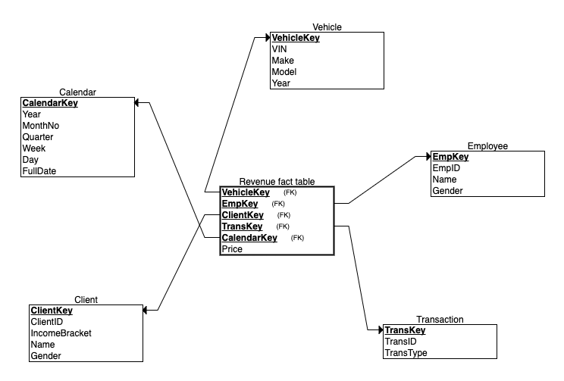**Module 4**